L3 Technologies

Multi-Robot SLAM

 

10//2017

ME 423-X2

Roger Kleinmann

Christina Maher

Kelly Munyan

Max Panoff

I pledge my honor that I have abided by the Stevens Honor System.

Table of Contents

**Section 1: Project Definition & Plan** **2**

1.1 Mission Statement 2

1.2 Background 2

1.3 Stakeholders 7

1.4 Project Scope 8

1.5 Project Plan 9

**Section 2: Design, Evaluation & Optimization** **9**

2.1 Requirements 9

2.1.1 Product Perspective and Intent 9

2.1.2 Primary Functions 9

2.1.3 Operating and User Environments 10

2.1.4 System Requirements 11

2.1.5 Hardware Requirements 12

2.1.6 Software Requirements 13

2.2 Constraints & Assumptions 15

2.2.1 Design and Implementation Constraints 15

2.2.2 Assumptions and Dependencies 15

2.3 Applicable Codes & Standards 15

2.4 Concept Development & Selection 16

**Section 3: Appendices** **22**

A: Team Organization Chart 22

B: Project Gantt Chart 23

C: Stakeholder Needs, Target Metrics and Specifications 25

Appendix C1: Stakeholder Needs 25

Appendix C2: Target Metrics and Specifications 27

D: References Cited 28

# Section 1: Project Definition & Plan

## 1.1 Mission Statement

The purpose of this project is to develop an efficient and accurate system for navigation and mapping within unknown naval vessels. Oftentimes foreign ships must be boarded before admission into port, or abandoned vessels will be inspected for hazards. In either case, it is necessary for sailors to enter every time despite use of human resources and potential dangers. In small scale situations, inspection tasks can be taken over by single robot systems, allowing a single human operator to remotely and safely inspect an area of interest. However, in the aforementioned cases, a single robot cannot complete the task efficiently. The proposed system shall consist of multiple autonomous robots capable of developing a single, consistent and accurate map of previously unknown environments. This will allow for safer inspection of vessels with the use of fewer human resources

## 1.2 Background

Robots have been expanding into previously human dominated fields in recent years, for a multitude of reasons. They do not need breaks or take time off, making them more reliable than human workers. Also as products, they are purchased, meaning one, large, up front cost; which simplifies company cash flow. The real weakness of robots however is their rigidity. Humans can adapt to new, unknown situations much better than machines can. This project will be utilizing robots in an unknown environment, and as such will be making use of several strategies and sensors to increase the flexibility of robots, allowing them to move into a new field: security. Firstly, machine learning is a relatively new strategy that has emerged in recent years, which focuses on training a computer system to solve a specific problem. The system gets “trained” via machine learning where using several test cases the system begins to identify patterns in them which can then carry over to non-test images for actual implementation. The downside to this is a long “training” period, and the fact that the training is very calculation heavy, but sufficient processing power greatly speeds up this process. Once trained however, the system is very flexible adapting to new situations by recognizing established patterns and drawing inferences from their precedence. LiDAR will be the main sensor used in this project, which stands for light detection and ranging, which works by sending out light pulses and measuring the time it takes to return, giving a distance to an object. This grants 360 degree distancing, easily allowing reconstruction of the external environment.

*1.2a Example of how a 2d lidar system would interpret the floor plan of a room (Salman)*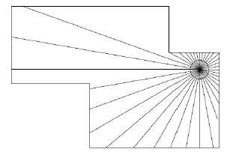

*1.2b Visualization of how a 3d lidar system understands its surroundings (Kushleyev)*

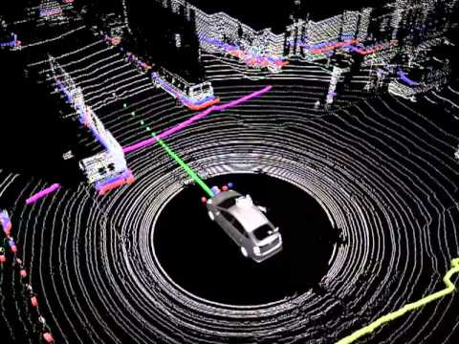

By utilizing LiDAR a simultaneous mapping and localization (SLaM) Algorithm can be implemented. This allows the robot to identify and map external features and identify where in the map it is located.

*1.2c Example of how a robot utilizing SLaM may build a map of its surroundings and move through the environment (path outlined in red) (Salman)*

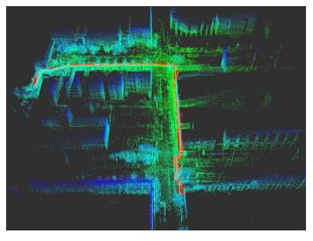

This is one of the premier ways to navigate spaces as it can be highly accurate and does not rely on external communications, which are weaknesses that gps based systems have. SLaM is also useful because small errors due to randomness of sensor readings can be filtered out via kalman filter. Kalman filters utilize estimations of “states” to determine the likelihood of a reading and tuning results to match preconceived guesses of what should be seen. These are very useful for SLaM based systems as the robot knows both its surroundings and where it is in relation to these surroundings, so it can very accurately determine if a reading makes sense by comparing it to concrete facts. For example a room in a ship will not suddenly change dimensions, so if data comes back suggesting that it has, it can be thrown out. Perhaps the most import aspect of this project is the fact that it is composed of multiple robot platforms making up a single system. This technique has several obvious benefits, namely that data can be collected from multiple places at once, leading to a larger area serviced. It has some other strategies to increase efficiency as well, namely by optimizing roles. A multi robot system can delegate different tasks to different robots, with each specializing in a single area. An example of this would be if a faster “scout” platform equipped with lidar quickly mapped out areas while slower platforms with a variety of sensors followed, examining the room via camera and using machine learning to identify objects of interest or anomalous environmental conditions. Roles can also be more abstract however, with the platforms acting only as data gathering drones, and utilizing a much more processing power heavy hub to deal with analyzing the data and plotting paths for the drones to take.

L3 Technologies has tasked this group to develop a system utilizing all of these strategies which will focus on patrolling US Navy ships. L3 is focused on communication systems for these ships and is looking to identify a better method of securing areas aboard ship. This would not be the company's first foray into sensor systems, and they are hoping to make this project into a highly versatile system that will be able to operate in a variety of situations. They already produce a few autonomous systems, and robotic simulators, and as a sponsor of an international high school robotics competitions, they see the use of robots in industry and are working on expanding their reach.

There are several existing systems which attempt to do something similar to this project. Perhaps the closest analogue to this Multi-Robot SLaM System in objective is KnightScopes Autonomous Data Machines (ADMs). These robots are designed to patrol and monitor spaces for companies, acting as force multipliers for human security. They come with a variety of sensors and methods of interacting with humans in their zones, such a speakers for connecting guards and nearby people, cameras for surveillance, and environmental sensors to ensure that they remain safe (KnightScope Inc). Though ADMs are similar in purpose, they carry out their tasks very differently. They utilize gps systems for determining patrol routes, instead of a slam system, and they were designed to be used in moderate to high traffic areas with people around to interact with.

The major differences between the ADMs and the Multi-Robot SLaM System is in how they monitor surrounds and the degree of human interaction the platforms were expected to have. This project focuses on static landscapes where shifting environments should be minimal, humans in the zone of operation are anomalous and are treated as such. As such, sensors need to only notice movement and location of objects, if either phenomenon occurs, it should be noted. The GPS geofencing technique used by KnightScope would also prove to be ineffective in implemented on a moving object such as a ship, a self contained localization system is required. Because both mapping of surroundings and localization are necessities, SLaM is the obvious forerunner for such a system. Lastly, while both ADM’s and the Multi-Robot system utilize algorithms to identify if anomalous conditions are met, the flexibility of this project’s machine learning puts it far ahead. Where an ADM relies on more binary information, like whether a metal detector detects metal, the Multi-Robot SLaM System can detect via camera if it sees a gun, or if there happens to be piping running along the nearest wall. Because it can identify objects via image to can be told to search for a specific instance of an object, and more importantly, determine between similar objects without needing user input, freeing up humans to work on other tasks.

1.2d *A KnightScope ADM on patrol (KnightScope ADM)*

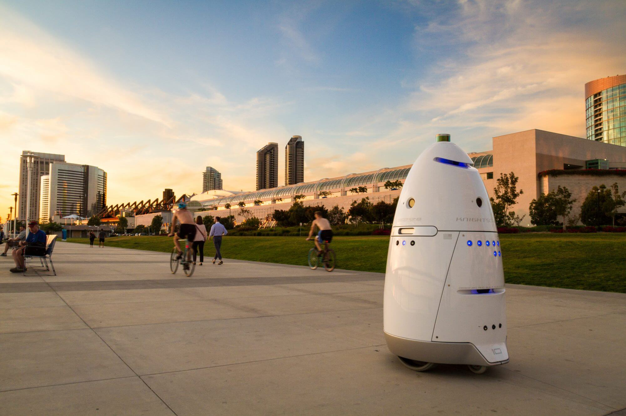

A product that is more similar in design philosophy to this project would be the Pure Technologies pipe inspector. It utilizes 3d LiDAR and SONAR to detect the shape and state of the pipes it inspects, as well as the health of the pipe. Because of the high resolution of these sensors corrosion can be found on pipes without physical testing. The system also supports live CCTV viewing of the camera allowing for the detection and inspection of anomalous objects. The system also supports mapping out the pipes that it passes through so suspicious areas can be easily found in the future. A second pipe cleaner is the FAST system by GE. It utilises brushes for cleaning as it passes through, inspecting welds and walls via ultrasound for signs of corrosion and structural issues. Both of these systems are teleoperated instead of autonomous, meaning that increases in labour efficiency are minimal.

None of these robots are a true competitor to the Multi-Robot SLaM system. This system will focus on mapping surrounding via LiDAR similar to how the FAST and Pure Technologies products do, but for very different reasons, instead of examining pipes, the Multi-Robot SLaM System will be looking at secure areas aboard ships, comparing the mapped areas to known schematics are looking for movement where none should be. It will also utilize this map for obstacle avoidance, and route planning, rather than relying on human operators. Most significantly there will be multiple robots to collect this information, and each will have to combine its data, forming a single coherent map. While all three platforms have camera systems for visual identification, the Multi-Robot SLaM system uses it to look for objects of interest without human input, only notifying a user if one is found. By utilizing machine learning and image processing the system can be trained to identify certain types of objects sounding an alarm in one is spotted. Due to the amount of autonomous behavior this system exhibits it greatly reduces the amount of human labour needed to patrol sensitive areas, a major improvement over these other systems.

## 1.3 Stakeholders

After preliminary market research and with the guidance of the project abstract, a list of primary stakeholder needs and their target specification metrics and values were created. From the initial project abstract and description, the team determined many primary needs that the system needs to meet in order to be successful and to meet the needs of the primary stakeholders. The primary stakeholders for this project are L3 Technologies Communication Systems-East, as they are the sponsor of this project, as well as the students and staff of ME-423-X1 (Interdisciplinary Senior Design Course). The main primary needs of this network of multiple robots are the following: Inspect the internal areas of a ship with minimal interactions from a human; create a 3D map of the areas and deliver to human operator; and, communicate with other robots in network to merge data into a single map. These primary needs are the basis for the project, and further stakeholder needs were developed. The detailed list of stakeholders and stakeholder needs can be found in Appendix C1. Along with the needs of the system, target metrics and specifications were created to generate guidelines for the main goals of the project. The specification metrics and units are listed below in 1.3a.

*1.3a Specification Metrics*

|  |  |  |
| --- | --- | --- |
| **Metric #** | **Specification Metric** | **Specification Unit** |
| 1 | Cost | Dollars ($) |
| 2 | Weight | kg |
| 3 | Translational Speed | m/s |
| 4 | Rotational Speed | rad/s |
| 5 | Battery Lifetime | Hours |
| 6 | Charging Time | Hours |
| 7 | Range of Motion | Degrees (°) |
| 8 | Size | Cubic Inches (in^3) |
| 9 | Temperature Range | Degrees Fahrenheit (°C) |
| 10 | Lifetime | Years |
| 11 | Design Timeline | Months |
| 12 | Payload | kg |
| 13 | LiDAR Detection Distance | mm |
| 14 | RealSense Detection Distance | m |
| 15 | Processing Power | GHz |

A detailed list of target metrics and specifications and their relation to the stakeholder needs can be found in Appendix C2.

## 1.4 Project Scope

This project strives to create a three robot system that will be able to integrate 2D LiDAR maps with a 3D depth camera to develop a 3D map of the internal areas of ships. While this system is being designed for an area within a ship, there are also constraints that this environment places on the system such as size, mobility, and the type of information that is of interest. Additionally, the robots must be able to store and send the data to a remote user which presents its own challenges in being able to pass data on ships where a wireless signal is usually absent. The initial design of this system will be structured to function on both commercial and naval vessels but could be later applied to other structures such as abandoned buildings or foreign aircraft.

Additional deliverables expected from this project include multiple reports describing the progress achieved by the team throughout the year as well as presentations to inform both the sponsor as well as the advisor and class of the current status of the project and where the team is focusing their energy next. A budget must be kept and abided by to ensure that the team is efficient with resources as to not waste any of the sponsor’s money. The team must meet the deadlines set by the Senior Design ME-423-X2 course syllabus as well as any deadlines created by the sponsor. The team has set their own internal goals of finishing the programming of one robot to have full functionality within the first half of the project and focusing on the integration of the other robots into the system throughout the second half.

## 1.5 Project Plan

The team approached this project by first dividing the semester up by the three milestones as outlined by the course guidelines. By doing this, the team was able to determine when they wanted their own internal milestones to be delivered. These include tasks such as when to order the necessary materials including the robots and how to split their time up into research, coding and other tasks required to successfully complete the project. The team will split into smaller sub-teams once the architecture of the system is finalized. However, the entire team is researching ROS and SLAM. The team organization role in Appendix A details the roles of each member for the work up to and including milestone 1. The team also generated a timeline for the semester that they hope to follow in order to achieve their immediate goals for the semester. This timeline is included in the Gantt Chart in Appendix B.

# Section 2: Design, Evaluation & Optimization

## 2.1 Requirements

### 2.1.1 Product Perspective and Intent

By integrating a technological mapping system into a ship’s inspection procedure, companies can save countless resources both financially and in the labor necessary to complete the procedure. A fleet of integrated robots would replace the common place crewman by inspecting incoming foreign ships or abandoned vessels for any suspicious or abnormal objects. By deploying this system, the safety of the crew would be upheld as any dangers that may be present would be found before the crew was aboard. The system would create a comprehensive 3D map of the interior areas of the ship that could later be analyzed by a crew member. These robots would also be able to map regions that were previously inaccessible to the crew, therefore allowing for a more complete inspection to be performed. This map and corresponding information would then be sent to a central computing system for the maps for processing and analyzing. Additionally, the central computing system would send a signal to the individual robots for them to return to the start location once the comprehensive map is complete. By implementing this system, resources, such as time and energy, are saved as well as the safety of the crew being improved should a danger be present on board.

### 2.1.2 Primary Functions

The major function of this design is to integrate three individual TurtleBot mobile ground robots to create one complete system or fleet. Each TurtleBot includes a 2D LiDAR sensor that would allow for a 2D map of the area in question to be created. In order to create these maps, the robots will need to use Simultaneous Localization and Mapping (SLAM) on the Robot Operating System (ROS). This map will serve as the foundation for the 3D depth camera that is also included on each TurtleBot. After creating the 2D map, the robots will then paste a 3D version on top to create a 3D map of the area surveyed. Once each TurtleBot has mapped its portion of the total area, the data will be sent to a central computing system to integrate the maps together and form a complete 3D map of the entire area. This map can then be reviewed by a human operator to determine if there are any abnormalities.

An additional function of this design is that the three individual robots would be able to return to the starting place after the area has been mapped. This would encompass having some device acting as a stationary marker to denote the central location for the robots to refer back to. The robots will be sent a signal from the central computing system once the entire map is merged and complete. Once the robots receive this signal, they will evaluate the map and find the most efficient route back to the stationary marker. To keep this system as efficient as possible, the local computing system will direct the robot’s path to keep them from colliding and mapping the same area. The idea of returning to the start location will also be utilized when the robot’s battery life is below a certain level. The central computing system will monitor the battery levels of each individual robot and send out a similar signal for a robot to return to the starting location for charging.

The system must also be compatible with a human interface. A remote user would be necessary to deploy the system onto the ship and to set the starting position. Additionally, the robot system would need to store the data it collects in order to send it back to the central computing system for the map merging. In future developments of this system, the central computing system would receive the data in real time so that the robots themselves do not need to the same level of storage as being used in this prototype. Once the comprehensive map is completed, a human operator would be able to review the map for any abnormalities for further investigation.

### 2.1.3 Operating and User Environments

The environment in which this design would be primarily used is a commercial or naval vessel. When a foreign ship comes into port or a vessel is found abandoned, an initial inspection must be done to insure that there is no danger present on board. Through the use of this system, the users can stay on land and away from any potential harm while the robots search the ship. These systems would need to be versatile to be used in any area that would need inspection such as hallways, cargo holds, or common areas. The main purpose of this robot system is to perform a preliminary inspection of unknown vessels to keep the crew out of harm. Any concerns would be captured on the map and reviewed on land before a crew is deployed to perform further investigations. This system can be applied to multiple environments and structures that would need this preliminary inspection.

In order for this system to work properly, multiple subsystems are required. In addition to the 2D LiDAR and 3D depth camera that are included with the TurtleBot platform, Simultaneous Localization and Mapping (SLAM) and Robot Operating System (ROS) would need to be implemented. Aside from the software included on the robot, a power system will need to be included to ensure that the TurtleBots are able to recharge and collect an acceptable amount of information before having to recharge. An additional system would have to be included to account for the remote user and the functionalities allowed them. The user would have to be trained in ROS and SLAM in order to give instructions to the robot system to allow for the detection of specific objects. Training in reading the 2D and 3D maps created by the system would also have to be performed to ensure that all users were able to read and review any information that the system may output.

### 2.1.4 System Requirements

With the primary functions and operating environment defined, the system, hardware, and software requirements can be explored. The functional system requirements are laid out in 2.1.4a.

*2.1.4a Functional System Requirements*

|  |  |  |
| --- | --- | --- |
| ID | Requirement | Imp. |
| SYS1.1 | The system shall be able to autonomously generate a 3D map of its environment. | 3 |
| SYS1.2 | The system shall produce a visual representation of the generated map for the human operator. | 2 |
| SYS1.3 | The system shall be composed of a network of robots. | 3 |
| SYS1.3.1 | The system shall allow the robots to communicate together to merge the individual maps to a single, consistent, accurate map. | 3 |
| SYS1.3.2 | The system shall allow each individual robot to recognize other robots and adjust the path accordingly. | 2 |
| SYS1.4 | The system shall be able to autonomously avoid all obstacles. | 2 |
| SYS1.5 | The system shall allow for use of software and hardware integrated together. | 3 |

(SYS1.1) and (SYS1.3.1) are the foundational requirements of this system in that - without their successful function - the system will fail immediately. They focus on the autonomous mapping and navigation of the system. Multiple robotic platforms are to be used, therefore it is not feasible for mapping and control to be fulfilled through teleoperation (by full control of the human operator) deeming the aforementioned requirements necessary. Another major requirement is (SYS1.3), and is established because a network of multiple robots allows for faster data acquisition and more frequent patrolling of the environment. (SYS1.3.2) is integral for both obstacle avoidance and merging of maps as recognizing robot location, dimension, and trajectory can allow for more advanced evasion as well as simplifying merging algorithms by comparing robot location. Lastly, (SYS1.5) is necessary as the different hardware components (computer, sensors, motors, etc.) must function as a unit as well as be compatible with the programming languages and packages selected by the team.

*2.1.4b Non-Functional System Requirements*

|  |  |  |
| --- | --- | --- |
| ID | Requirement | Imp. |
| SYS2.1 | The system shall be safe for human operators and humans in the environment. | 3 |
| SYS2.1.1 | The system shall not have a physical impact on the layout of the operating environment. | 2 |
| SYS2.1.2 | The system shall have sounds levels less than 80dB. | 1 |
| SYS2.2 | The system shall be useable in a large operating environment with discrete areas. | 1 |
| SYS2.3 | The system shall provide real-time map information to the human operator. | 1 |

The non-functional system requirements outlined in 2.1.4b address features that would enhance the use of the system without being integral to its functionality. (SYS2.1) outlines safety as one of these features as it technically has no impact on the success of the design, but should be heavily considered nonetheless. (SYS2.3) is a feature of the user interface, providing updated map progress during human operation, and is a desirable feature for stakeholders, but is not necessary given that the system will create the map autonomously for later analysis.

### 2.1.5 Hardware Requirements

The functional hardware requirements are listed in 2.1.5a. They describe the essential attributes of the hardware the robots will need to successfully complete this project.

*2.1.5a Functional Hardware Requirements*

|  |  |  |
| --- | --- | --- |
| ID | Requirement | Imp. |
| HDW3.1 | The hardware shall be able to process data from multiple high demand sensor devices | 3 |
| HDW3.2 | The hardware shall be able to sense objects from distances of at least 2m | 2 |
| HDW3.3 | The hardware shall have a mobile power supply | 3 |
| HDW3.4 | The hardware shall relay information wirelessly to other detached hardware components | 2 |
| HDW3.5 | The hardware shall have a means of recording 3D environmental data | 3 |

(HDW3.1) is one of the most important hardware requirements of the system. In order to navigate and collect useful information - especially at a fast rate - multiple sensor devices must be implemented and operable from a single computer. In addition, if only one sensor device is included in the initial system, it may be necessary to add additional devices, in which case the computer must have the processing capacity for expansion. (HDW3.3) is also an important hardware requirement as the system must be fully mobile to explore large spaces. A tethered supply is not feasible for exploration of complex environments. While the system could function with only a means of navigation, the objective of the device is incomplete without 3D mapping capabilities as described by (HDW3.5). Producing 3D maps is important as it both allows for identifying floor plans and object outlines.

*2.1.5b Non-Functional Hardware Requirements*

|  |  |  |
| --- | --- | --- |
| ID | Requirement | Imp. |
| HDW4.1 | The hardware shall be able to travel at a top speed of at least 20 cm/s | 2 |
| HDW4.2 | The hardware shall be able to run continuously for at least 1 hour | 3 |
| HDW4.3 | The hardware shall be no more than 40cm in length in any direction | 1 |
| HDW4.4 | The hardware shall be modifiable for later addition of additional sensors and beacons | 2 |
| HDW4.5 | The hardware shall have the capacity to be used with a variety of navigation strategies in case pivoting is necessary | 1 |

(HDW4.2) is a non-functional requirement because the system should be capable of completing a single task within the period of an hour, but if the battery life is shorter, solutions can be developed to split work over time, speed up navigation efforts, or allow charging in-between tasks. Additionally, (HDW4.4) would make it easier for robots to recognize each other, but is not integral to system success. (HDW4.1) is also not a necessary requirement as tasks can be completed at slower speeds, but shorter completion times are more desirable to the stakeholders.

### 2.1.6 Software Requirements

The functional software requirements are listed in 2.1.6a. They describe the crucial requirements that the software should include.

*2.1.6a Functional Software Requirements*

|  |  |  |
| --- | --- | --- |
| ID | Requirement | Imp. |
| SFW5.1 | The software shall gather data from its surroundings at a sufficiently high rate | 3 |
| SFW5.1.1 | The software shall gather 2D LiDAR data at a rate of at least 10Hz | 2 |
| SFW5.1.2 | The software shall gather data from the camera at a rate of at least 30 Hz | 1 |
| SFW5.2 | The software shall be able to create, support, and modify a map of the System’s surroundings | 3 |
| SFW5.2.1 | The Software shall be able to integrate 2D LiDAR data into this map | 2 |
| SFW5.2.2 | The Software shall be able to integrate data from a point cloud into this map | 2 |
| SFW5.3 | The Software shall allow communication between different instances and users | 3 |
| SFW5.4 | The software shall be able to identify a wide variety of objects and alert a user if one shows up on the camera | 3 |
| SFW5.5 | The software shall support a Graphical User Interface which displays the current map and allows user interaction | 1 |
| SFW5.1 | The robot can gather all data at a rate of at least 10Hz | 2 |
| SFW5.2 | The system can share data between its parts at a distance of 10 meters | 3 |
| SFW5.3 | The system should be able to display data collected as a map | 2 |
| SFW5.5 | The system should be able to function independent of human input | 3 |
| SFW5.6 | The system should be able to navigate to certain points it has already mapped | 2 |
| SFW5.7 | The system should be able to display rgb/depth images from robots | 1 |

(SFW5.1) is completely essential requirement for this project, if data is gathered too slowly it will lead to issues with all of the system’s functions. A low sampling rate leads to a large amount of issues with prediction and state simulation, and may cause issues with object avoidance. Communication in the system is also very important for a project like this. If the robots act as isolated systems then each will have to map the entirety of their surroundings, instead of each mapping a portion, defeating the point of the project (SFW5.3). (SFW5.4) encompasses the the second portion of this project, with image processing and machine learning identification. Without a large variety of objects in a “library” that can be easily identified, this project will be very limited in its duties.

*2.1.6b Non-Functional Software Requirements*

|  |  |  |
| --- | --- | --- |
| ID | Requirement | Imp. |
| SFW6.1 | The Software shall be capable of emergency shutdown from a user | 2 |
| SFW6.2 | The software shall have basic security, a password to access the network the platforms are on | 3 |
| SFW6.3 | The code shall be well documented | 1 |

(SFW6.2) is a requirement as securing the system is of the utmost importance as it will be implemented in a defense oriented environment. Access to the data and monitoring may facilitate security breaches and as such needs to be tightly regulated.

## 2.2 Constraints & Assumptions

### 2.2.1 Design and Implementation Constraints

There are multiple design and implementation constraints that this project much take into consideration Firstly, cost is a major limiting factor both during prototyping and when commercialized; as keeping costs under budget is essential, to both engineers and customers.a second constraint is size of the platform. This product will be navigating the inner workings of a ship, a location where space is always at a premium. Keeping the design small is an essential consideration that must be made. The processing power that the system has is also limited. Thought must be given as to what data must be processed, when and where. Maximizing the efficiency of that limited resources must be done. Finally, battery life is the last major constraint. Power is another limited resource on a ship so this design must make good use of what it is given.

### 2.2.2 Assumptions and Dependencies

It is assumed that the user of this product will be a trained adult, serving on a ship. It is also assumed that this project will be used on ships, where the platforms can freely navigate. Another assumption is that every surface that is to be scanned can be reached by the system. The lighting is assumed to be even and moderate. It is assumed that the system will be utilized in low traffic areas, and that it will be able to easily navigate said areas and through doorways.

## 2.3 Applicable Codes & Standards

Applicable codes and standards vary based on the type of ship and the type of cargo that the ship is carrying. However, the International Maritime Organization (IMO) is the organization responsible for implementing and amending various codes “as per types of ships, goods or cargoes, Cargo operation, maritime security, shipbuilding, the safety of the crew, training, etc. (Bhattacharjee)”. If a ship fails to comply with these codes, they could face legal liabilities. Some of the various maritime codes that particularly pertain to the addition of the robot aboard a ship are described below.

The International Ship and Port Facility Security Code (ISPS) is a code that protects international security. The main aims of the ISPS Code are to control unauthorized people from accesses controlled areas onboard ships and at any port, to monitor cargo activity, to monitor people activity, and to measure security threats and act accordingly. Other aims are to create and implement responsibilities to port state officers and officers on board ships to respond to international threats, and to collect and act on global data regarding security concerns. This code is relevant to this project as the network of robots will be monitoring cargo and could potentially be used to monitor cargo activity. Additionally, the team wants to ensure that the robots while sending data, does not prove to be a security issue (Wankhede).

The International Safety Management (ISM) Code is a code that is used daily aboard ships as it is in place to detail the safe management and operation of a ship as well as pollution prevention. This code requires the creation and implementation of a safety management system to achieve the safety-management objectives created by the company. This code is pertinent to the project as the team has to ensure that the addition of a network of robots fits inside a variety of safety management systems (“ISM Code and Guidelines”).

The Code of Safe Practice for Cargo Stowage and Securing (CSS Code) aims to promote safe practices for stowing and securing cargoes on a ship. This code has a variety of different ways to ensure that the cargo is properly stowed and secured including ensuring the ship is being used for it’s purpose in regards to cargo and ensuring that the ship has proper securing equipment. This code also has advice for many different circumstances like bad sea conditions, cargo shifting and other conditions. This code is relevant to the project as the team should be aware of how cargo is typically stored and if any of the securing means would provide difficulties for monitoring and inspecting the internal areas of a ship (“Code of Safe Practice”).

Other regulations that the team should be aware of are International Traffic in Arms regulations (ITAR) and Export Administration Regulations (EAR). These regulations both control the import and export of defense related products. In the case that this system does fall under either of these regulations, the team will need to ensure that they are compliant with the regulations to ensure the proper import and export of any software, hardware and information gathered by the robots. Additional codes and standards may become applicable to the team as the project progresses. This includes other codes and standards that may be applicable to the technology, software and hardware contained on the robots.

## 2.4 Concept Development & Selection

For this robotic system, concept generation occurs in two stages. First, strategies for operation are developed and analyzed based on system requirements (2.1.4a and 2.1.4b). Second, the hardware requirements for the system (2.1.5a and 2.1.5b) are evaluated and robot platforms are researched and broken down. From these devices, a final platform is selected based on criteria primarily based on hardware requirements as well as ability to comply with the ideal strategy (otherwise another strategy must be developed).

Several points were developed regarding strategy for operation of the system. These included concerns for both direct human interaction and robot communication. These points are outlined as follows:

1. What will be the level of manual control (teleoperation)?
2. How will the system be initialized?
3. Will there be any level of environmental instrumentation?
4. What will be the modes of localization?
5. What decisions will be made local to each robot vs. on a remote computer?
6. Will there be hierarchy to the robotic system?

Point (1) is important as it relies both on the environment of operation and number of human resources available. In order to reduce the number of operators, each robot within the system will be able to function entirely autonomously during navigation and mapping. Not only will this allow for fewer operators, but designing for full autonomy will result in better operation at long distances and unknown spaces where constant communication may be impossible or costly. Initialization of the system (2) is another concern to design for and is dependent on the situations for operation. For investigation of foreign or abandoned vessels, the robots should be deployable from a distance before beginning mapping tasks. For this reason, the current system should allow a human operator to remotely control a single robot platform (to which the other platforms with follow) in order to direct the system to a safe starting point. Because the environment will be previously unknown, the system should be able to operate with limited or no environmental instrumentation (3). Point (4) is mostly dependent on the hardware capabilities of the robot platforms, but because 3D maps will ultimately be produced, the primary mode of localization will be through these mapping devices (likely 3D depth camera). Additional sensors such as 2D LiDAR (if available) may be used to improve the accuracy of these maps. Points (5) and (6) can be answered simultaneously as immediate processing and exploration tasks will run on individual platforms while map merging and group decision making will occur on an off-board computer. Group decisions include allocating areas to explore based on the status of the existing map, sending signals for robots to return upon map completion, and running path planning algorithms using the completed map to find the shortest route back to the starting position. For the first stage of this project, all robots within the team shall complete the same tasks and have the same capabilities, sending and receiving information to and from a common off-board computer. However, for the final system, operating range may be limited, so a single robot may act as a mobile computer, deploying with the system and completing the aforementioned group decision making tasks.

With the system requirements and strategies in mind, four platform types were selected for analysis: Turtlebot 3 Waffle, Turtlebot 3 Burger, Turtlebot 2e, and Oculus Prime. Their characteristics are as follows:

**Turtlebot 3 Waffle**

* Price: $1,799
* Weight: 1.8 kg
* Translational Speed: 0.26 m/s
* Battery Life: 2.0 hr
* Controller/Processor: OpenCR(32-bit ARM Cortex-M7) with Intel Joule
* Sensors: Intel Realsense R200 (3D depth camera), HLS-LFCD2 (2D LiDAR), 3-Axis gyroscope, 3-Axis accelerometer, 3-Axis magnetometer
* Program: Robot Operating System (ROS) Kinetic
* Additional Notes: Packages already exist for SLAM of turtlebot robots. Turtlebot platforms also have excellent support and an already existing community of users. The Turtlebot 3 Waffle is low to the ground (resists tipping) and has many mounting points, making it easily modified.

**Turtlebot 3 Burger**

* Price: $549
* Weight: 1.0 kg
* Translational Speed: 0.22 m/s
* Battery Life: 2.5 hr
* Controller/Processor: OpenCR(32-bit ARM Cortex-M7) with Raspberry Pi 3
* Sensors: HLS-LFCD2 (2D LiDAR), 3-Axis gyroscope, 3-Axis accelerometer, 3-Axis magnetometer
* Program: Robot Operating System (ROS) Kinetic
* Additional Notes: Packages already exist for SLAM of turtlebot robots. Turtlebot platforms also have excellent support and an already existing community of users. Also, a Raspberry Pi 3 is not powerful enough to add additional process-intensive sensors such as a 3D depth camera, so other means of image acquisition would have to be used. The Turtlebot 3 Burger has several mounting points making it relatively easy to modify.

**Turtlebot 2e**

* Price: $1,900 (complete kit)
* Weight: Approximately 1.5 kg
* Translational Speed: Not listed
* Battery Life: Not listed
* Controller/Processor: 1.7 GHz quad-core Intel Atom T5700 processor or Netbook
* Sensors: Orbbec Astra or Microsoft Kinect (3D depth camera)
* Program: Robot Operating System (ROS) Kinetic
* Additional Notes: Many parameters for the the Turtlebot 2e are unlisted as distributors are beginning to integrate the new Turtlebot platforms and information is becoming limited. Many units are available as kits and may not include all components. Because kits require assembly and some customization, modification is very easy.

**Oculus Prime**

* Price: $1,399
* Weight: 2.5 kg
* Translational Speed: 0.4 m/s
* Battery Life: 4.0 hr
* Controller/Processor: ASRock J3710-ITX
* Sensors: Microsoft LifeCam Cinema (2d camera), Orbbec Astra (3D depth camera), 3-Axis gyroscope, Temperature, Battery current draw
* Program: Robot Operating System (ROS) Kinetic
* Additional Notes: The Oculus Prime platform has large wheels for high mobility. It relies exclusively on its 3D depth camera for navigation and mapping. There are no feasible mounting points making it difficult to modify.

The research that the team performed helped shape the team’s decision on a robot to purchase for the purposes of this project. A decision matrix was used to weigh different options for robot platforms. The team weighed various attributes for each of the robots using a decision matrix which is listed in 2.4a.

*2.4a Weighted Decision Matrix of Robot Platforms*

|  |  |  |  |  |  |  |  |  |  |
| --- | --- | --- | --- | --- | --- | --- | --- | --- | --- |
|  | | **Concepts** | | | | | | | |
| **Waffle (TurtleBot 3)** | | **Burger (TurtleBot 3)** | | **TurtleBot 2e** | | **Oculus Prime** | |
| **Selection Criteria** | **Weight** | **Rating** | **Weighted Score** | **Rating** | **Weighted Score** | **Rating** | **Weighted Score** | **Rating** | **Weighted Score** |
| Cost/quantity available | 15% | 3 | 0.45 | 8 | 1.2 | 2 | 0.3 | 5 | 0.75 |
| Processing Capability | 20% | 9 | 1.8 | 4 | 0.8 | 6 | 1.2 | 7 | 1.4 |
| Mobility | 10% | 6 | 0.6 | 5 | 0.5 | 5 | 0.5 | 7 | 0.7 |
| Capacity for Modification | 5% | 9 | 0.45 | 7 | 0.35 | 9 | 0.45 | 1 | 0.05 |
| Sensors Provided | 15% | 8 | 1.2 | 5 | 0.75 | 4 | 0.6 | 5 | 0.75 |
| Portability | 5% | 7 | 0.35 | 8 | 0.4 | 5 | 0.25 | 3 | 0.15 |
| Sensor Accuracy | 15% | 8 | 1.2 | 7 | 1.05 | 6 | 0.9 | 6 | 0.9 |
| Strategy Compliance | 15% | 8 | 1.2 | 4 | 0.6 | 6 | 0.9 | 6 | 0.9 |
| **Total Score** | | 7.25 | | 5.65 | | 5.1 | | 5.6 | |
| **Rank** | | 1 | | 2 | | 4 | | 3 | |
| **Status** | | Develop | | Reject | | Reject | | Reject | |

All four of these hardware options and criteria are evaluated in the weighted decision matrix shown above in 2.4a. From this matrix the Turtlebot 3 Waffle is found to be the best option due to its superior capacity for modifications, processing ability, sensor capabilities, and compliance with the aforementioned operation strategy. It is the most flexible platform among those listed, which is important as any changes in methodology throughout the project will be allowed for by the Waffle and few major modifications will be necessary. In addition, given complexity of a multi-robot system and the cost of each platform, three robots will be developed for this system. This number is selected as there are enough robots to increase efficiency and also potentially distribute tasks, but also few enough to minimize complexity of communication algorithms.

With the Turtlebot 3 Waffle selected, the next steps are to begin developing code followed by testing and implementation of mapping strategies. Following the development of code and testing with the selected platform will be key milestones for operation outlined in 2.4b.

*2.4b Development Milestones*

|  |  |  |
| --- | --- | --- |
|  | **Task** | **Expected Completion** |
| T1 | A single robot shall produce an accurate 2D map of an empty room | Semester I, Week 12 |
| T2 | A single robot shall produce an accurate 3D map of an empty room | Semester 1, Week 14 |
| T3 | A single robot shall produce an accurate 3D map of a similar room with few (2-4) obstacles | Semester II, Week 3 |
| T4 | A single robot shall produce an accurate 3D map of a similar room with several (6-8) obstacles | Semester II, Week 4 |
| T5 | A single robot shall produce an accurate 3D map of multiple rooms (3-4) sharing joining doorways | Semester II, Week 5 |
| T6 | All three robots shall produce an accurate 3D map of a single room through simultaneous operation | Semester II, Week 8 |
| T7 | All three robots shall produce an accurate 3D map of multiple rooms (3-4) sharing joining doorways | Semester II, Week 10 |

*NOTE: a) For evaluation, a single room is defined as a rectangular space with all entrances (doorways and otherwise) closed off and confined to a space of at least 5m in both horizontal directions. b) Obstacles are defined as items which can be bounded by a box at least 12” in all directions. c) Accuracy is acceptable with map inconsistencies no more than 2” from the expected value

# Section 3: Appendices

## A: Team Organization Chart

|  |  |
| --- | --- |
| **Team Member** | **Responsibilities** |
| Roger Kleinmann | * Concept Selection and Project Planning * Research SLAM and ROS Packages * SLAM/ROS Programming * System/Hardware Requirements * Competitor/Customer Analysis |
| Christina Maher | * Concept Selection and Project Planning * Budgeting and Systems Requirements * Competitor/Customer Analysis |
| Kelly Munyan | * Concept Selection and Project Planning * Stakeholder Needs and Target Metrics Tables * Secretary for All Group and Sponsor Meetings * Systems Requirements * Competitor/Customer Analysis |
| Max Panoff | * Concept Selection and Project Planning * Research SLAM/ ROS * Systems/Software Requirements * SLAM/ROS Programming * Competitor/Customer Analysis |

## 

## 

## 

## B: Project Gantt Chart

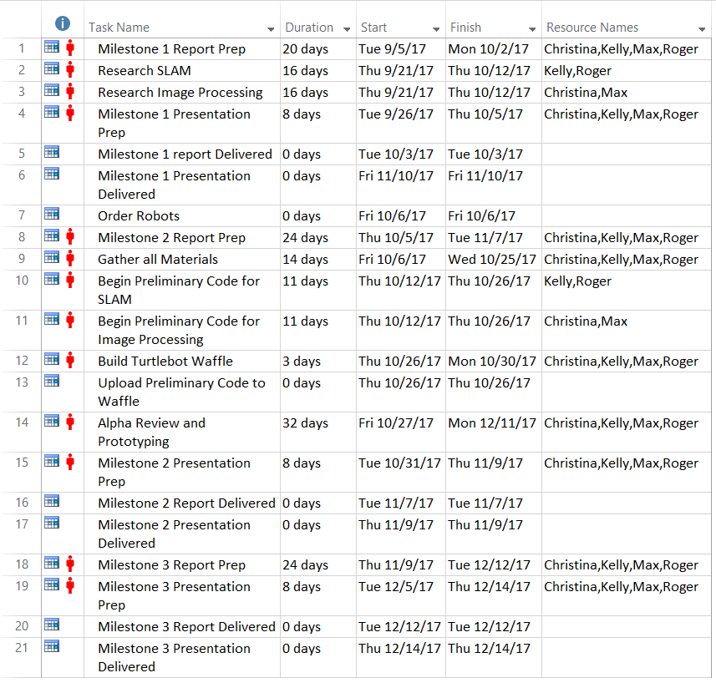

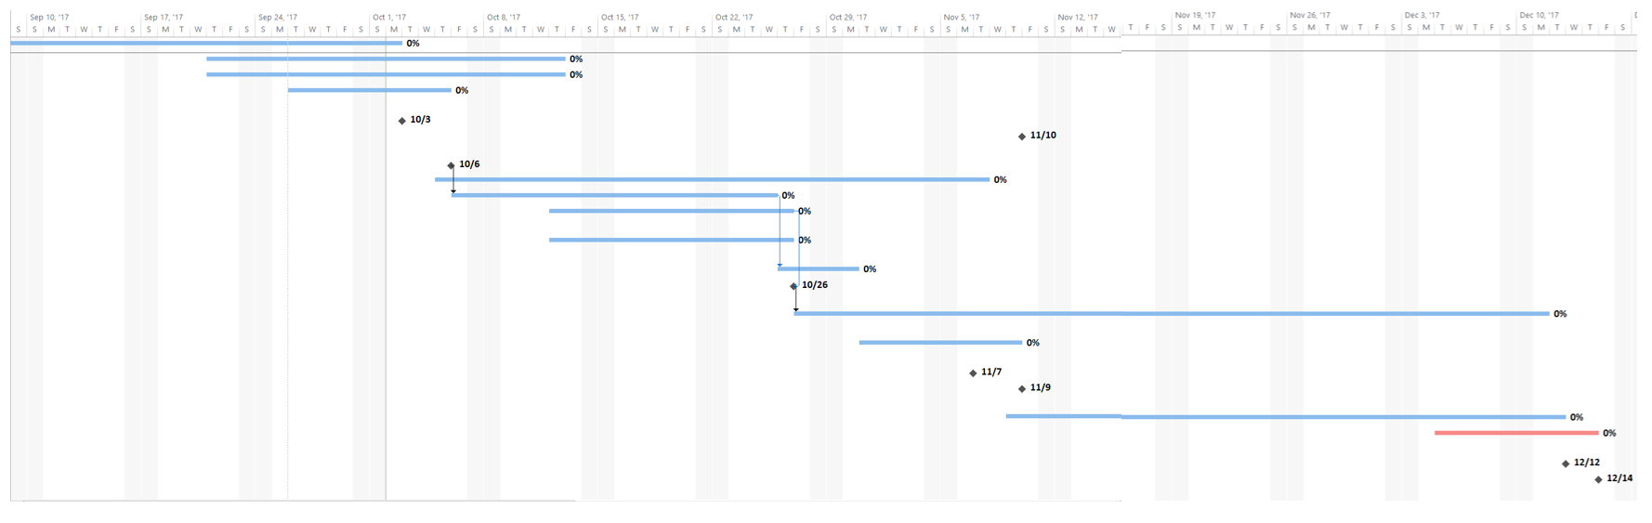

## C: Stakeholder Needs, Target Metrics and Specifications

### Appendix C1: Stakeholder Needs

|  |  |
| --- | --- |
| **Stakeholder Need Number** | **Stakeholder Need** |
| **1.0 L3 Technologies Communication Systems-East** | |
| 1.1 | The product shall fulfill all customer needs and specifications |
| 1.2 | The product shall operate safely. |
| 1.3 | The product shall be marketable. |
| 1.4 | The product shall be profitable. |
| 1.5 | The product shall be a beta prototype. |
|  | |
| **2.0 Users** | |
| 2.1 | The product shall operate safely. |
| 2.2 | The product shall be in a reasonable price range. |
| 2.3 | The product shall be reasonable in size. |
| 2.4 | The product shall be long-lasting and durable. |
| 2.5 | The product shall be mobile on its own. |
| 2.6 | The product shall autonomously generate a 3D map of its environment. |
| 2.7 | The product shall send the generated 3D map to the final destination. |
| 2.8 | The product shall communicate and merge data with multiple robots within the network. |
| 2.9 | The product shall successfully inspect the internal areas of a ship. |
| 2.10 | The product shall be able to interact with a human operator. |
| 2.11 | The product shall be able to autonomously avoid obstacles including other robots. |
| 2.12 | The product shall be able to operate at varying temperatures. |
| 2.13 | The product shall be appealing. |
| 2.14 | The product shall be moved easily. |
|  | |
| **3.0 Students and Staff of ME-423-X2** | |
| 3.1 | The product shall fulfill all requirements and deadlines set by the course expectations. |
| 3.2 | The product shall be reasonable and feasible to create with the given materials, time and restrictions. |
| 3.3 | The product shall be created within the given price range. |
| 3.4 | The product shall be created within the given time range. |
| 3.5 | The product shall be created using the Product Development Process. |
| 3.6 | The team members shall show the ability to successfully work in a team environment. |
| 3.7 | The product shall be a beta prototype. |
|  | |
| **4.0 Future Senior Design Groups** | |
| 4.1 | The product shall be well documented. |
| 4.2 | The product shall be developed to the beta prototype phase. |
| 4.3 | The team shall communicate work and progress. |
|  | |
| **5.0 Production Staff** | |
| 5.1 | The product shall be designed with future plans for mass manufacturing. |
| 5.2 | The product shall be designed with reasonable materials. |
| 5.3 | The product (materials, processes, etc.) shall cost less than the target market price. |
|  | |
| **6.0 Maintenance Staff and Service Staff** | |
| 6.1 | The product shall be designed with minimal scraps. |
| 6.2 | The prototype shall have a MTBF of 10 years. |
| 6.3 | The product shall be designed to have easily replaceable parts. |
| 6.4 | The product shall be designed and created using durable materials that meet the specifications of L3 Technologies. |
| 6.5 | The product shall not be damaged during creation or shipping. |
| 6.6 | The product shall be created using durable machines. |
| 6.7 | The machines used shall need minimal maintenance. |
| 6.8 | The machines used shall use easily interchangeable parts. |
|  | |
| **7.0 Legal Department** | |
| 7.1 | The product shall not use anything already copywritten from a different product/company/etc. |
| 7.2 | The product shall be patentable by L3 Technologies, if chosen. |
| 7.3 | The product shall follow all applicable standards, codes and laws. |

### 

### 

### Appendix C2: Target Metrics and Specifications

|  |  |  |  |  |
| --- | --- | --- | --- | --- |
| **Metric #** | **Specification Metric** | **Specification Unit** | **Target Value** | **Applicable Needs** |
| 1 | Cost | Dollars ($) | ~ $5,000+ | 1.3, 1.4, 2.2, 3.1, 3.2, 4.3, 6.3, 7.5 |
| 2 | Weight | kg | <3 kg | 1.2, 2.1, 2.3, 2.5, 2.14, 7.1, 7.4, 7.5 |
| 3 | Translational Speed | m/s | >.2 m/s | 1.2, 2.1, 2.5 |
| 4 | Rotational Speed | rad/s | >1.5 rad/s | 2.1, 2.7, 2.8, 2.9, 2.11 |
| 5 | Battery Lifetime | Hours | >1 hour | 7.2 |
| 6 | Charging Time | Hours | ~2.5 hours | 7.2 |
| 7 | Range of Motion | Degrees (°) | 360° | 2.7, 2.8, 2.9, 2.11 |
| 8 | Size | Cubic Inches (in^3) | 12,130 cm^3 | 1.2, 2.1, 2.3, 2.13, 7.5 |
| 9 | Temperature Range | Degrees Fahrenheit (°C) | >0°C & <40°C | 2.12 |
| 10 | Lifetime | Years | 10 years | 2.4, 7.2 |
| 11 | Design Timeline | Months | ~7 months | 1.1, 2.10, 3.3, 4.1, 4.2, 4.4, 4.5, 4.6, 4.7, 5.1, 5.2, 5.3, 6.1, 6.2, 8.1, 8.2, 8.3, 7.6, 7.7, 7.8 |
| 12 | Payload | kg | <30 kg | 4.1, 4.2 |
| 13 | LiDAR Detection Distance | mm | >3,000 mm | 2.6, 2.7, 2.9, 7.3 |
| 14 | RealSense Detection Distance | m | >2 m | 2.6, 2.7, 2.8, 2.9, 2.10, 7.3 |
| 15 | Processing Power | GHz | >1 | 1.3, 2.6, 2.7, 2.8, 2.10, 2.11 |

## 

## 

## 

## D: References Cited

Alex Kushleyev, Alex. *Visualization of LIDAR DATA*. [i.ytimg.com/vi/nXlqv_k4P8Q/hqdefault.jpg.](http://i.ytimg.com/vi/nXlqv_k4P8Q/hqdefault.jpg.)

Bhattacharjee, Shilavadra. *23 Important Maritime Codes Used in the Shipping Industry*. Marine Insight, 6 Sept. 2017, [www.marineinsight.com/maritime-law/21-important-codes-used-in-the-shipping-industry/.](http://www.marineinsight.com/maritime-law/21-important-codes-used-in-the-shipping-industry/.)

*Code of Safe Practice for Cargo Stowage and Securing (CSS Code)*. International Maritime Organization (IMO), 2017, [www.imo.org/en/ourwork/safety/cargoes/cargosecuring/pages/css-code.aspx](http://www.imo.org/en/ourwork/safety/cargoes/cargosecuring/pages/css-code.aspx).

“GE - FAST Platform” *General Electric*, GE Inspection Robotics, <http://inspection-robotics.com/fast-platform/>

*ISM Code and Guidelines on Implementation of the ISM Code*. International Maritime Organization (IMO), 2017, [www.imo.org/en/OurWork/HumanElement/SafetyManagement/Pages/ISMCode.aspx](http://www.imo.org/en/OurWork/HumanElement/SafetyManagement/Pages/ISMCode.aspx).

“KnightScope ADM on Patrol.” *KnightScope*, KnightScope, [s3.amazonaws.com/knightscopewebsite/wp-content/uploads/2016/11/17195008/IMG_8823-Edit11-2000x1333.jpg.](http://s3.amazonaws.com/knightscopewebsite/wp-content/uploads/2016/11/17195008/IMG_8823-Edit11-2000x1333.jpg.)

“Knightscope, Inc.” *Knightscope*, KnightScope, [www.knightscope.com/.](http://www.knightscope.com/.)

"L3 Technologies." *L3 Technologies*. L3 Technologies, [www.l3t.com/](http://www.l3t.com/)

Parker, Lynne E., Daniela Rus, and Gaurav S. Sukhatme. "Multiple Mobile Robot Systems."

*Springer Handbook of Robotics* (2016): 1335-384. Web.

“Pure Technologies - Robotic Pipeline Inspection.” *Pure Technologies*, Pure Technologies Ltd, <https://www.puretechltd.com/technologies-brands/pure-robotics>.

Salman, Mishah U. “Simultaneous Localization and Mapping (SLAM).” Stevens Institute of Technology.

Wankhede, Anish. *ISPS Code - The 9/11 After Effect. Marine Insight*, 19 Nov. 2016, [www.marineinsight.com/maritime-law/isps-codethe-911-after-effect/](http://www.marineinsight.com/maritime-law/isps-codethe-911-after-effect/).